**Flood Risk Assessment – Heijplaat Rotterdam**

Elco Koks & Hans de Moel

In this practical you will perform a flood risk assessment, investigate adaptation options, determine whether certain implementations are cost-effective and perform a small uncertainty and sensitivity analysis. The region we will focus on is the Heijplaat, a harbour area in Rotterdam that also occupies a residential quarter. This area is located outside the primary flood defences of the Netherlands, making it an ‘unembanked’ area. To get an idea of where it is located, look up ‘ Heijplaat, Rotterdam’ in google maps and orient yourself. As you will see it is located on the south bank of the river which flows through Rotterdam into the North Sea (Nieuwe Waterweg). At the end of this document you’ll find a couple of maps of the area, including a land-use map of the region. The area we will make calculations for is encircled in yellow. The whitish area represents the embanked area with the thick grey lines being the primary embankments. There are also maps showing flood depths over various magnitudes, represented in return periods, for the current situation and for 2100.

In the answer sheet, you can find all questions that need to be answered. Please only hand in the answer sheet.

1. **Getting started: Set up the python environment**

In this assignment (and several of the following assignments in this course) we will make use of Python scripts and Jupyter Notebooks. These notebooks are user-friendly and straightforward to use, but we need to install a few things to get it all working.

If you have not done so already, please download the latest version of miniconda from this link: <https://docs.conda.io/en/latest/miniconda.html>. Install it like you install any other program.

The next step is to create a virtual environment to work in. To do so, we take the following steps:

* Open an Anaconda Prompt
* Move to the directory where you saved the Flood Risk Assignment. To navigate through your directories, use cd **name_directory** to move forward and cd .. to move backwards
* Move to the directory **install**
* Now copy the following in the Anaconda Prompt:
  + conda env create -f environment.yml
* Let conda do its job.
* After installing is finished, move to the directory ‘Notebooks’ in the Anaconda Prompt.
* Now activate your new conda virtual environment as conda activate ClimatePolicy
* Now type ‘jupyter notebook’
* This should open up in your default browser. We are now ready to go!

1. **Damage calculations**

To calculate the potential flood damage, we use stage-damage curves, which relate water depth to the fraction of maximum damage that can be sustained by a certain land use. As you can see on the land-use map at the end of this document, there are a lot of land use classes (53), though not all will suffer damage from flooding. For each of the land-use classes a curve (see graphs below) and maximum damage (see table below) number are assigned. For buildings, this is done for damage to the structure (i.e. the walls and such), as well as the content (i.e. furniture).

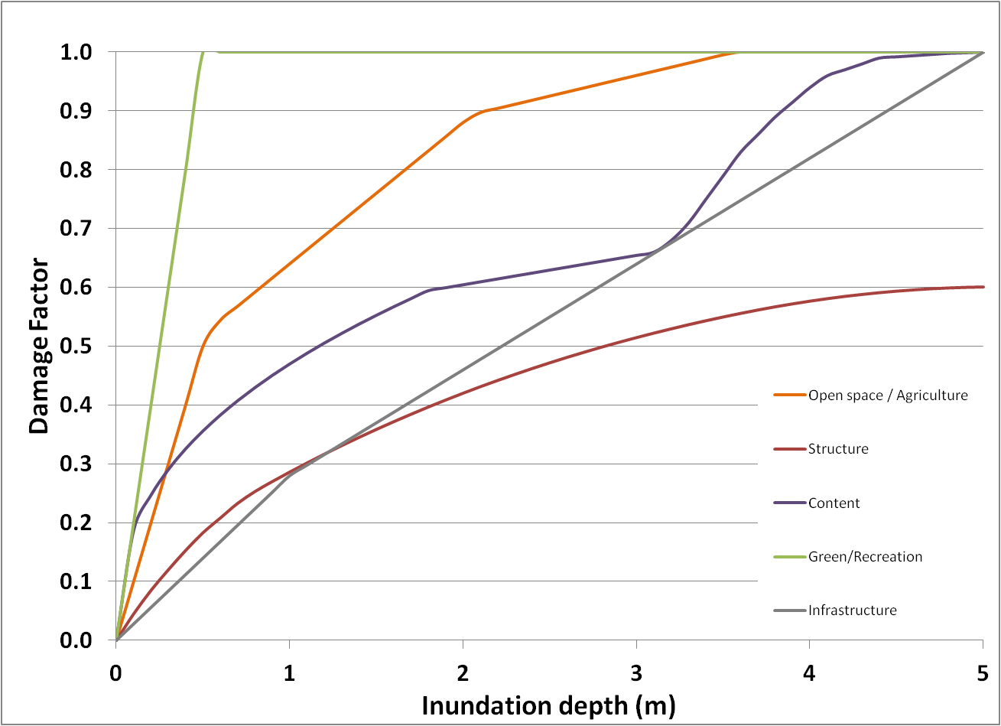



With these curves and maximum damages, the damage of a potential flood event can easily be calculated. Open the IPython notebook ‘Damage Assessment.ipynb’. The script is fairly short and in the third cell you can define the inundation map you want to use in the calculation (see also the comment). There are inundation maps for six different return periods: 10, 100, 1000, 2000, 4000, and 10000 years. Make sure to start with inundation map for a 1/10 flood and run the script (i.e. press ‘shift enter’ to run a specific cell). The total damage is printed below the cell, and you can also find it by printing ‘damage_total’ in a cell below.

To get a better insight into what constitutes the total damage, you can find the damage per land-use class in the parameter ‘damagebin_total’. Run the damage calculation for a return period of 1/100 years and print the output. (Answer Q1-Q3)

1. **Risk calculation**

By integrating damages of different return periods (i.e. calculating the area under the risk curve), the expected annual damage (or risk) can be determined. Open the IPython notebook ‘Risk Assessment.ipynb’. You’ll see a bit longer script now, but everything is set up for the first run. Go to ‘Kernel’ and press ‘Restart & Run all’. Verify that the damages here for the six return periods are the same as you calculated before.

Now we will take a look at how climate change may adversely affect flood risk for the Heijplaat area. This means that instead of the six inundation maps we’ve used before, we need the ones in which climate change (sea-level rise and higher river discharges) is accounted for. These maps are number a2 instead of a0. In the script you’ll see that we make sure we get the right flood maps for the current and the future at line 12-15. Re-run the notebook again for the ‘2100’ scenario. (Answer Q4-Q6)

1. **Adaptation measure**

In order to reduce the vulnerability of houses to flood damage, they can be adapted in such a way that water won’t cause too much damage. This is known as wetproofing. We can look at the effect of wetproofing by adjusting the stage damage curves and then redoing the damage and risk calculations. We’ll assume that wetproofing will reduce flood damage by 55% up to 2 m, then with 15% between 2 and 3 meter; and no effect above 3 m.

Create a new instance of the file ‘DDM_data.xlsx’ and give it a new name (we don’t want to overwrite our original data). Open that new file and go to the ‘curves_structure’ sheet. Now change the new structure curve in the column for land-use category 111 to reflect the effect of wetproofing. Do the same for the new content curve (in the ‘curves_content’ sheet). Please also create a figure that shows the new curves. (Answer Q7)

1. **Cost-benefit analyses**

Open the IPython notebook ‘Cost-Benefit Analysis.ipynb’. Now we can adjust the script in **Cell 5** to import these new curves, referring to the file you just saved. Now you can calculate the effect of wetproofing of houses on the flood risk by running the script. Do this for 2100, and also for the current situation. The next step is to calculate the total avoided losses over a certain timespan. Let’s assume that the measures will last for around 50 years, using a discount rate of 4%.

While wetproofing may reduce flood losses, they come with a cost as well. To compare the costs versus the benefits, cost-benefit analyses (CBA) are often performed to see if it’s economically worthwhile to invest in such a measure. We know that wetproofing costs around 7000 euro for an average house. Use this number in and look at the Benefit-Cost ratio (B/C). If the B/C ratio is larger than one and the NPV is positive, then it is worthwhile to invest in the measure that is evaluated. (Answer Q8-Q11)

1. **Uncertainty analysis**

Finally we want to see how sensitive our results are for the choice of the values of our input variables. Open the IPython notebook ‘Uncertainty Analysis.ipynb’. In **Cell 4**¸we set up everything for the uncertainty and sensitivity analysis. In the fifth line of this cell, we need to specify the bounds for the 3 inputs that we want to vary: the height of the inundation depths, the maximum damage value and the shape of the vulnerability curves. We will perform the analysis for the 1/10,000 flood map in the current situation. Once you have put in the bounds, go to ‘Kernel’ and press ‘Restart & Run all’. (Answer Q12-Q13)

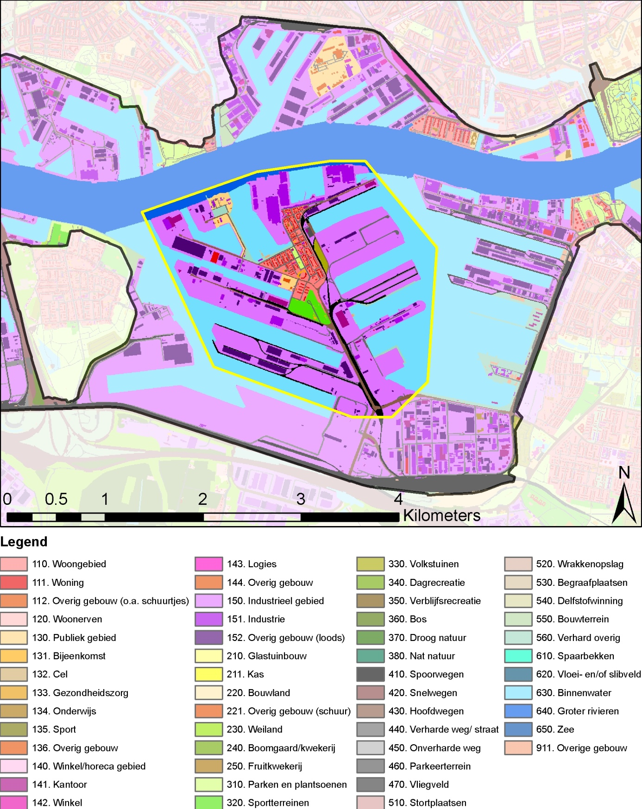

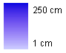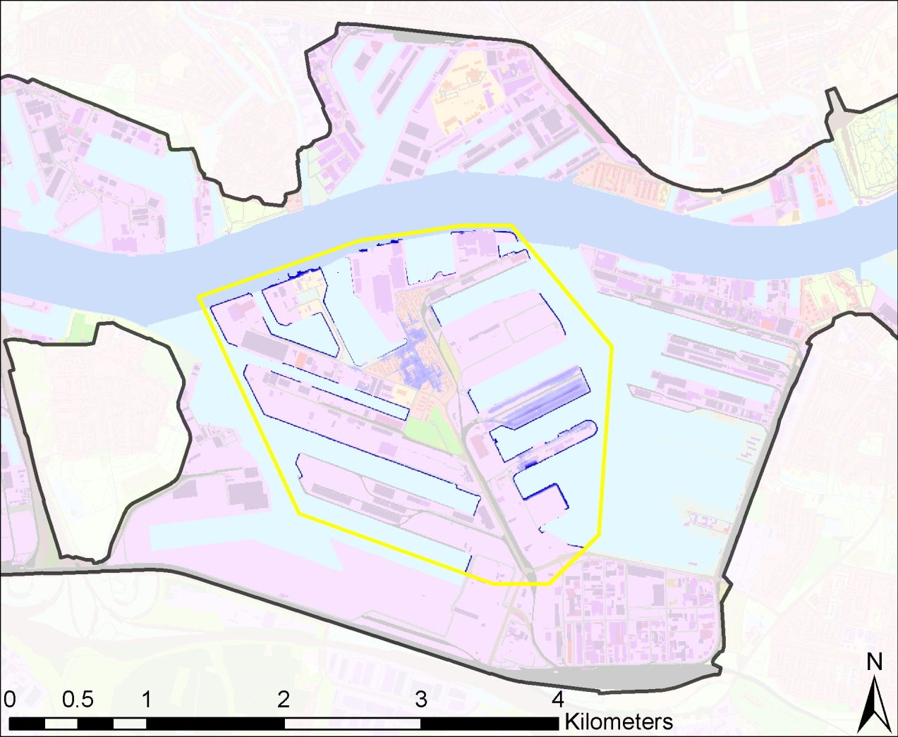

**Water Depth 1/100 years**

**Current conditions**

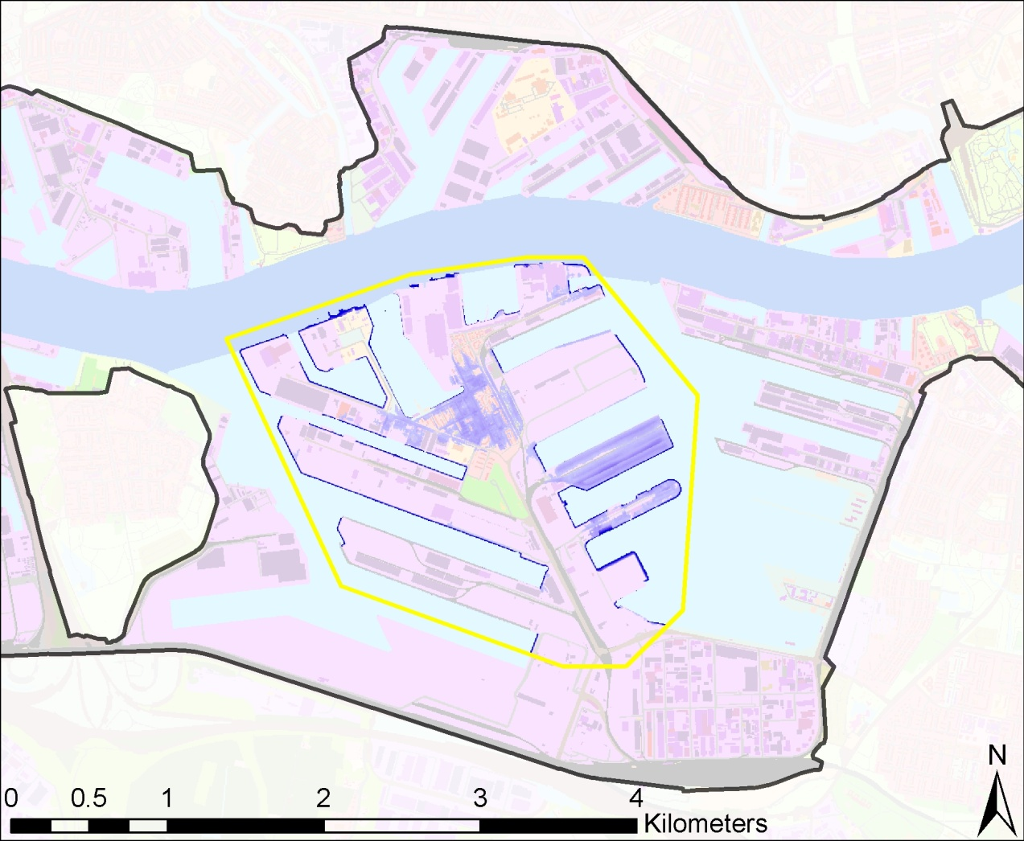

**Water Depth 1/100 years**

**2100 AD**

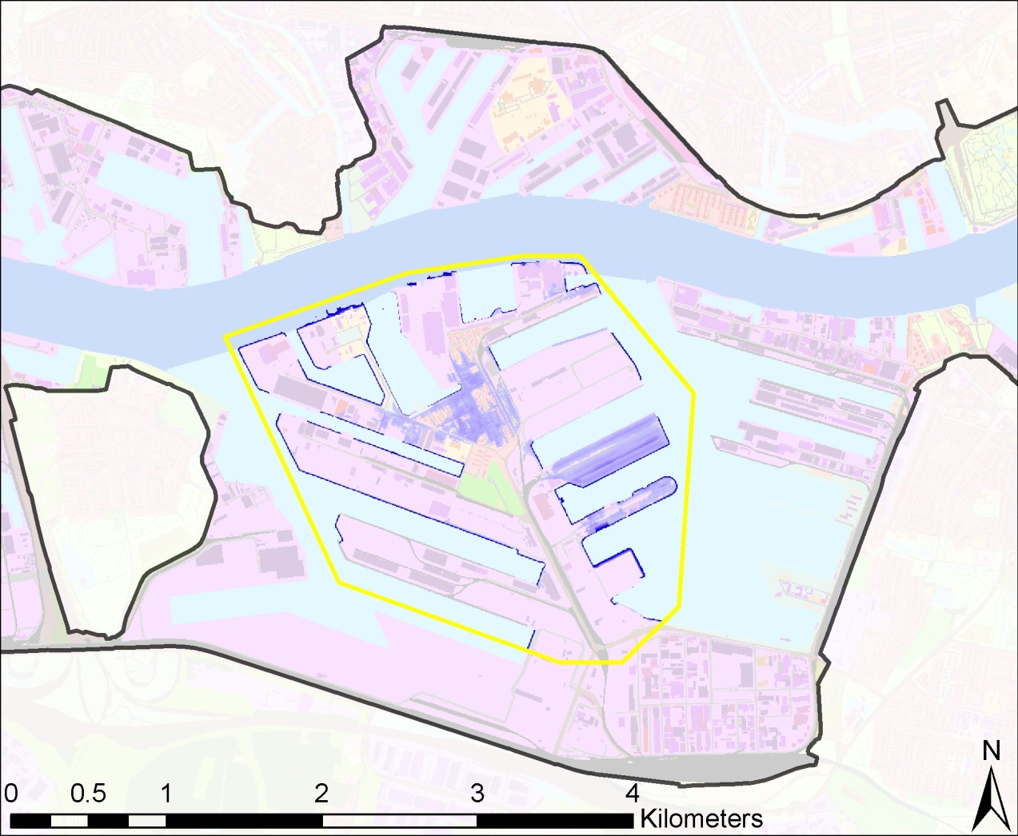

**Water Depth 1/1000 years**

**Current conditions**

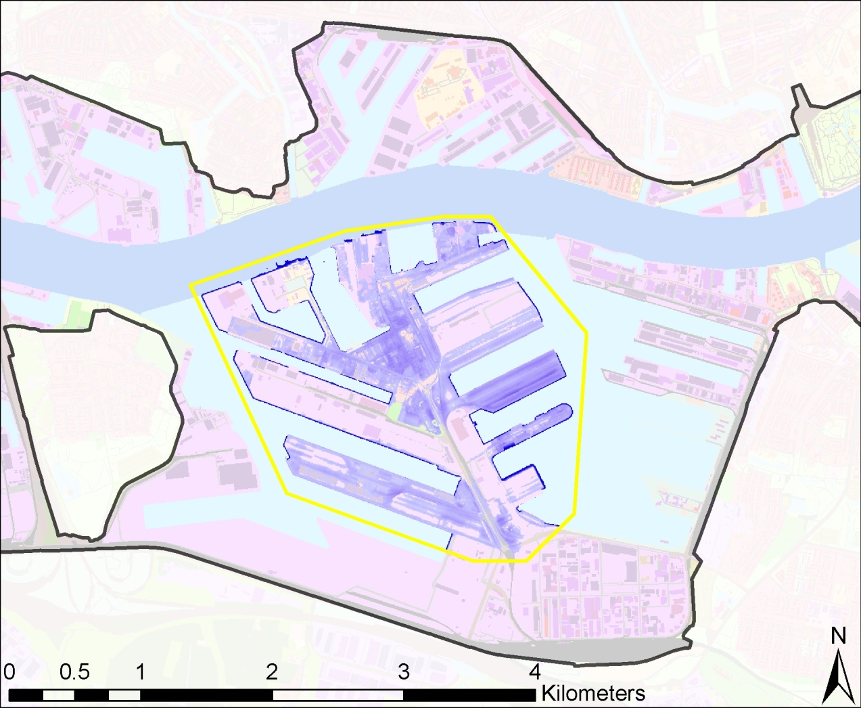

**Water Depth 1/1000 years**

**2100 AD**

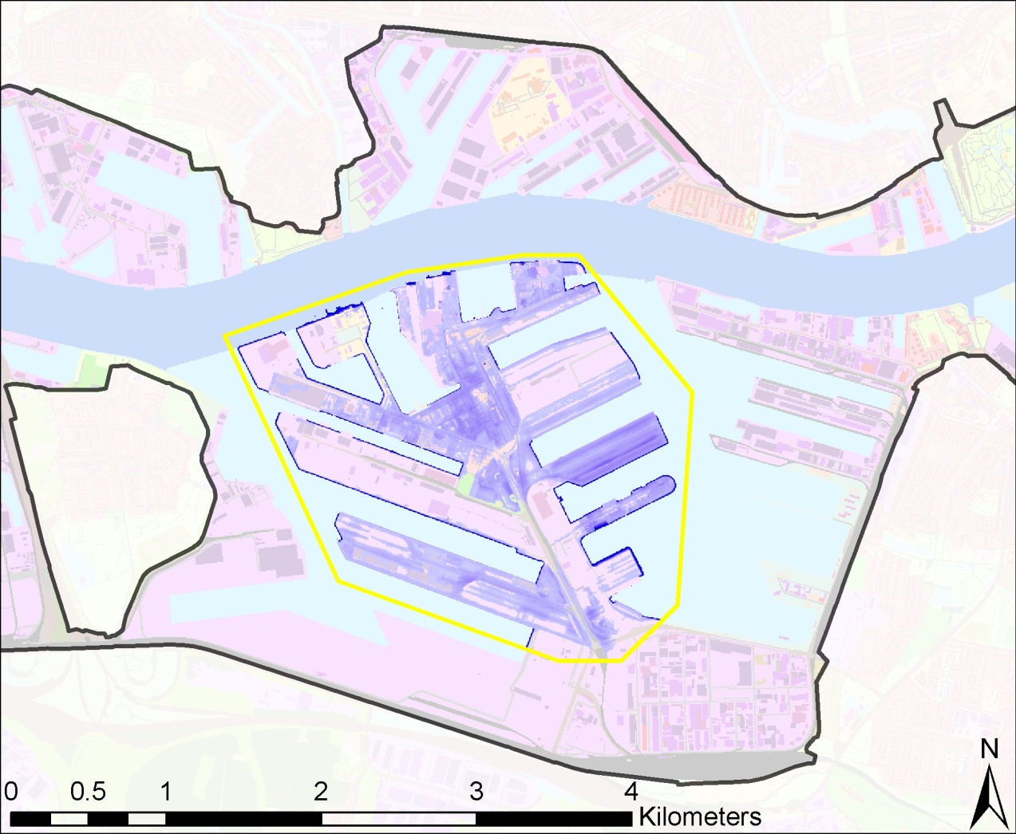

**Water Depth 1/10000 years**

**Current conditions**

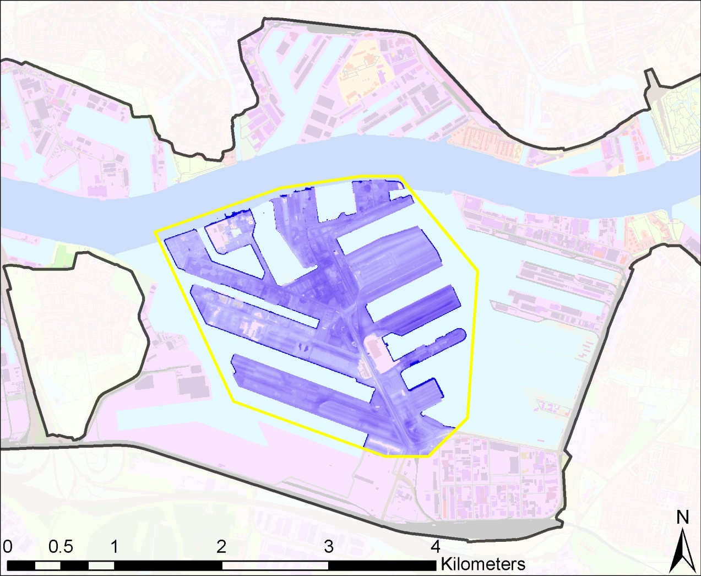

**Water Depth 1/10000 years**

**2100 AD**